



**Rwanda Food and Drugs Authority MIS User Manual**

Manual Contents

1 System Login 4

1.1.1 User login process 4

1.1.2 Password reset 4

2 Inspection Module 6

2.1.1 GMP Inspection 6

2.1.2 Initiating GMP Inspection Applications 6

2.1.3 Initiating New GMP Application 6

2. When the user clicks the New Application button the user is prompted with some options to choose between depending on the new application the user is about to make. 6

2.1.4 New GMP Application Process 7

2.1.5 Local Technical Representative 9

3 GMP Application Processing 18

3.1 Receipting and Payment Verification Process 18

3.2 GMP (Assigning GMP Screening) 19

3.3 GMP Screening 20

Then click submit an application from this pop-up screen. 20

3.4 GMP Inspection Type Categorization 21

Click submit an application from this pop-up screen. 21

3.5 Manager GMP Inspection Scheduling 22

3.6 Inspection stage 24

3.7 Inspection Reports Review (Manager) 25

3.8 TC Meeting Scheduling 26

3.9 TC Recommendation Review 28

3.10 Review & Approval 30

3.11 Communication with Applicant Process 31

3.12 Application Archiving Process 32

# Creation of User Account

The following form captures the user registration details which allows for the the ICT team to register the user and map the correct User Permissions

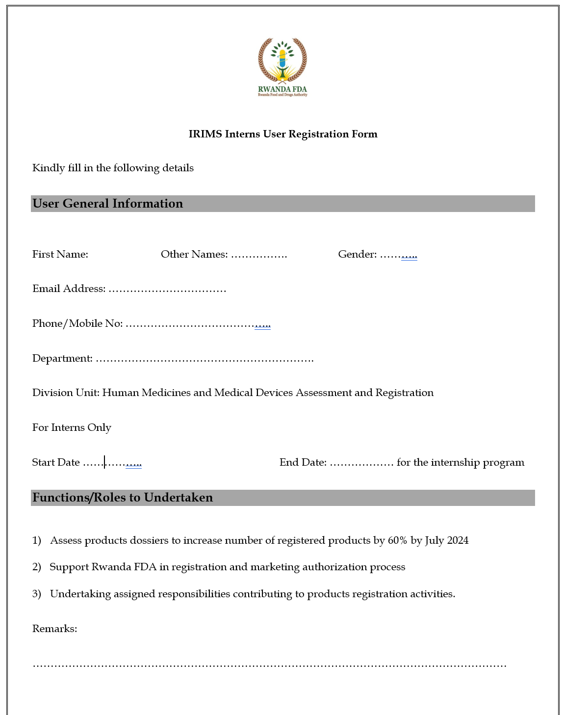

User Creation

User Account Features

* Upload of the User Photo
* Save or Update the User Information
* Filling in the user details based on the fill user registration form

Mapping of the User Permissions

# System Login

The user will be required to input the credentials (Email Address and password) and click **log in**.

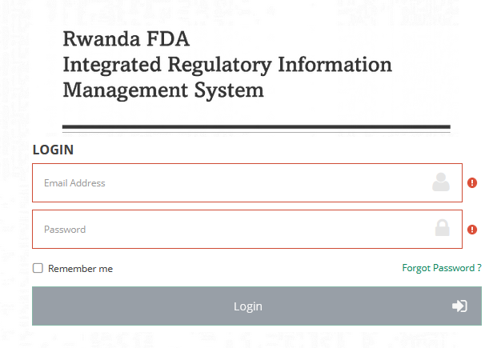

### User login process

* Step 1. Enter the User Email Address-User is required to enter a valid Email Address that is associated with the account.
* Step 2. Enter User Password-User is required to enter a secure password associated with the account.
* Step 3. Click the Login button to navigate to the Main dashboard-After a user has entered a valid Email Address and password should click the login button to navigate to the main page (Dashboard).
* Step 4. Click Forgot Password button-This button is helpful when a user is not able to remember the password associated with the account. This helps in resetting the password.

When the user fails to enter the correct Email Address and password the system will give an error message with a login failure notification and the number of remaining login attempts.

### Password reset

One can initialize the password reset process by clicking the Forgot Password button.

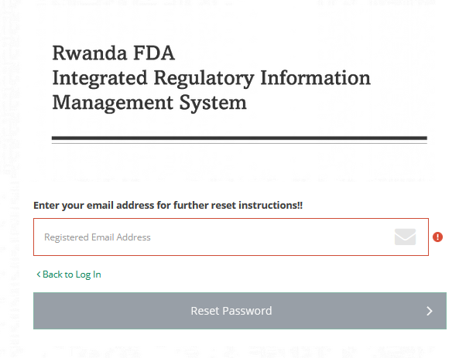

The process of password reset involves the following steps

* Step 1. Enter Registered Email Address-User is required to enter the Email Address registered with the account one is trying to reset a password.
* Step2. Click the Reset Password button--After a user has entered the Registered Email Address should click the Reset.

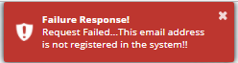

# Inspection Module

### GMP Inspection

**Good Manufacturing Practice (GMP)** is a system for ensuring that products are consistently produced and controlled according to quality standards.

1. While at the dashboard the user will be required to navigate to the Inspection  **Module** and select **GMP Inspections**.

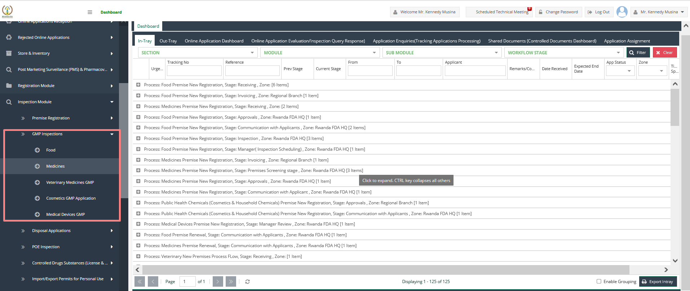

### Initiating GMP Inspection Applications

* Step 1 Select **GMP Inspection**
* Step 2 Select from the lists of GMP Inspections from the Inspection Module
* Food GMP Application
* Human Medicine GMP Application
* Cosmetics GMP Application
* Medical Devices GMP Application
* Veterinary Medicines GMP Application

### Initiating New GMP Application

1. **New Application** button- On click of this button user is directed to the new GMP application page where one can make an application for a new GMP.

### When the user clicks the New Application button the user is prompted with some options to choose between depending on the new application the user is about to make.

* New GMP
* GMP Renewal
* GMP Withdrawal
* GMP Alteration
* GMP Data Clean-Up

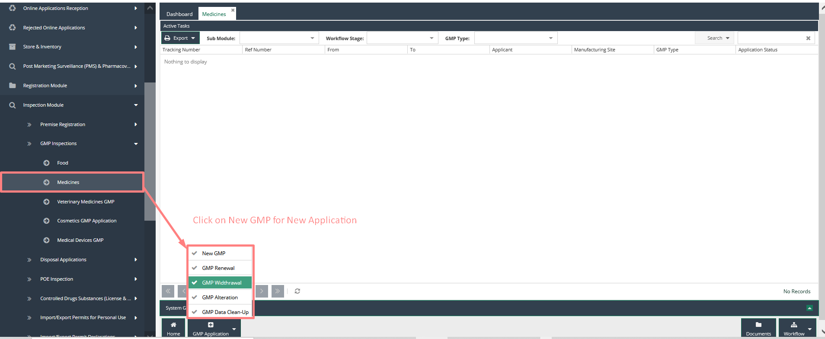

### New GMP Application Process

1. While making a new GMP application one is supposed to follow several steps.

**Step 1 Filling details on Applicant and Agent details section**

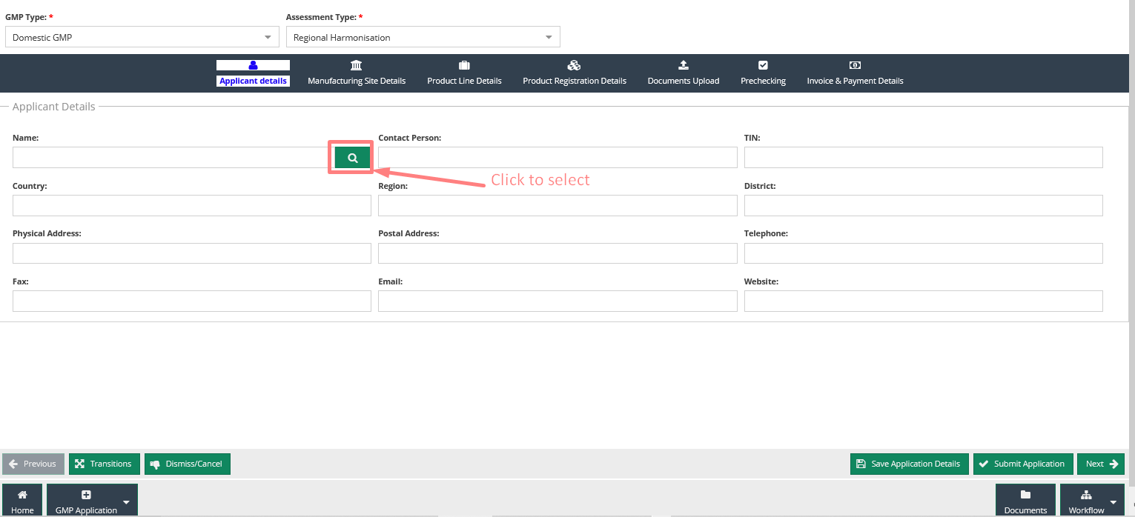

To add a new applicant double click on the user select button then navigate to **New Trader** **Information** Section and fill in all the required details to add a new trader. 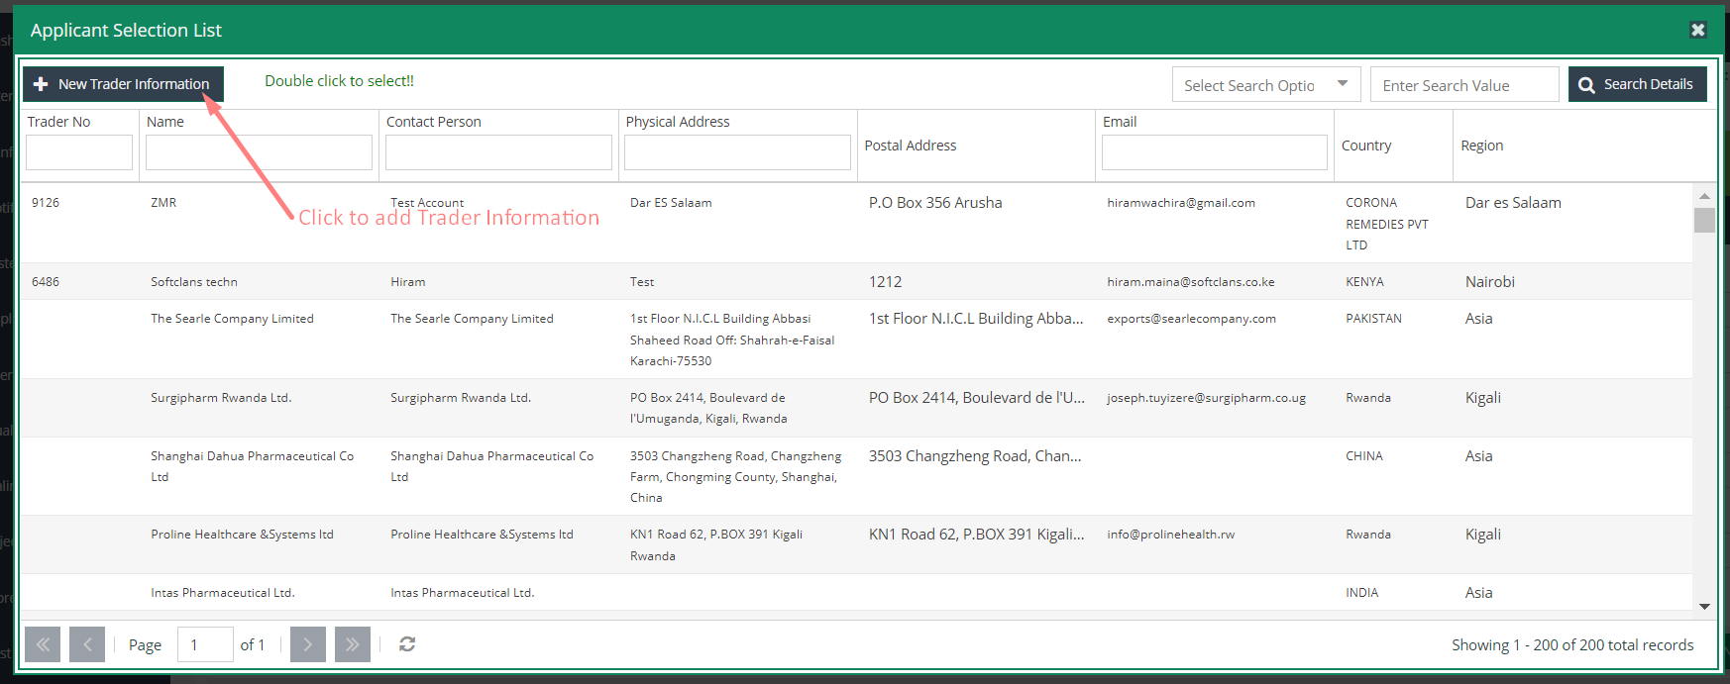

**Step 2 Filling details Manufacturing Site Details Section**

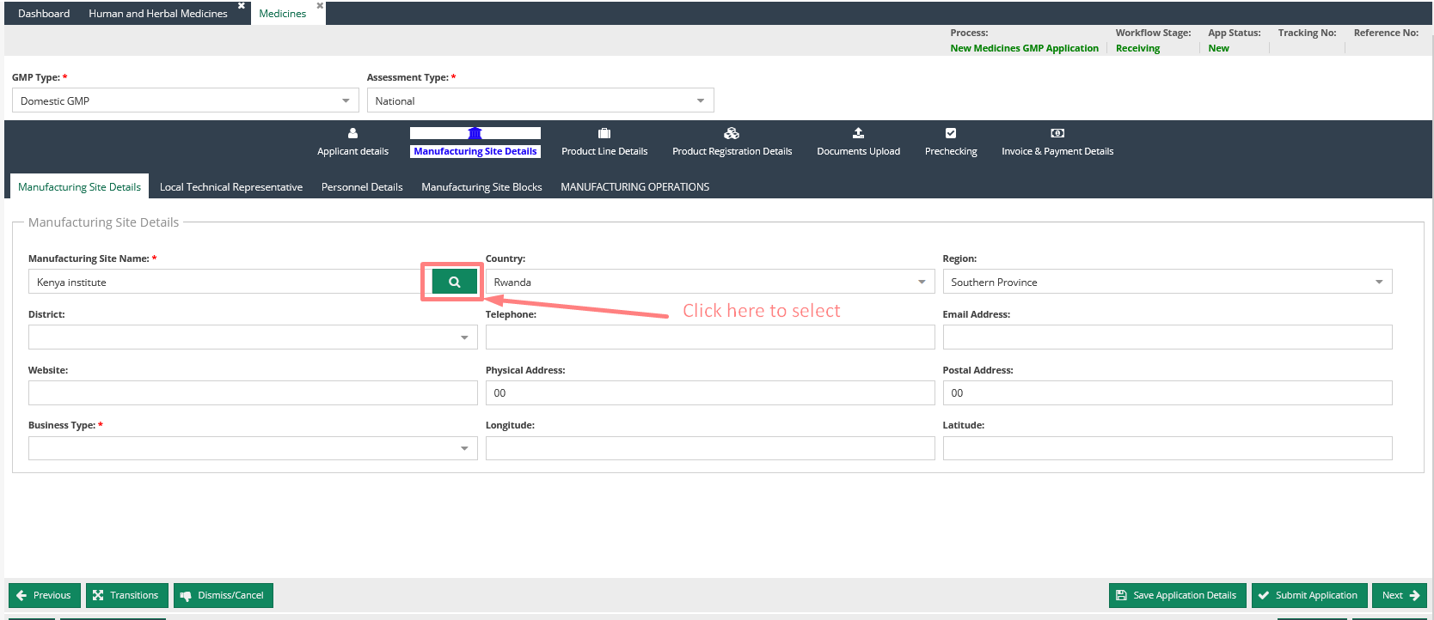

To add a manufacturing Site Details, select manufacturer and then double click on the user select button

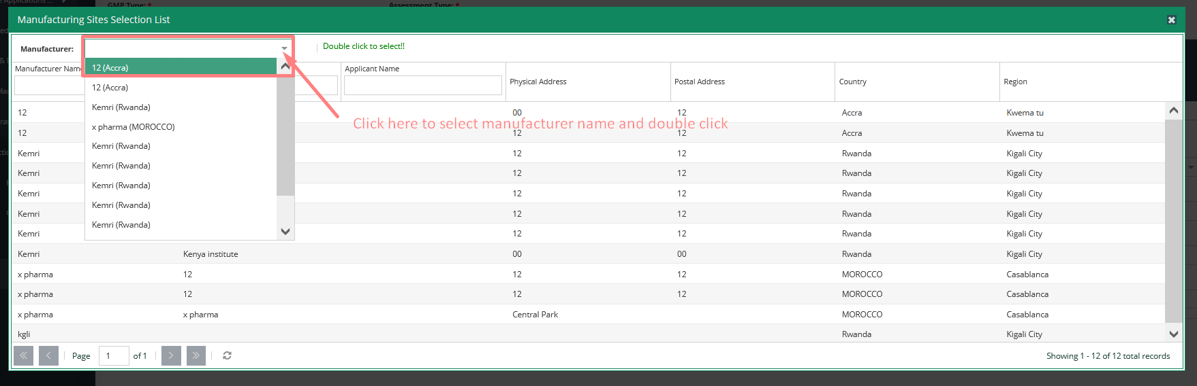

On the initial save of the application, a tracking number is generated and a notification pop up displayed.

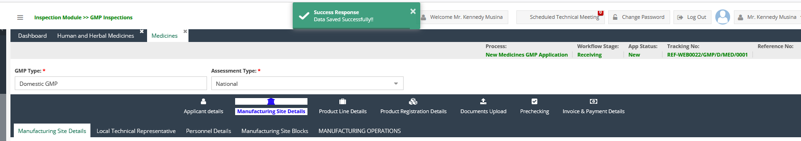

#### **GMP other details**

This section covers details that involve modules such as:

### Local Technical Representative

* Personnel Details
* Manufacturing Site Blocks
* Manufacturing Operations

Manufacturing Site Blocks and Manufacturing Operations provide an option to add a new item, that when clicked pops up the add form.

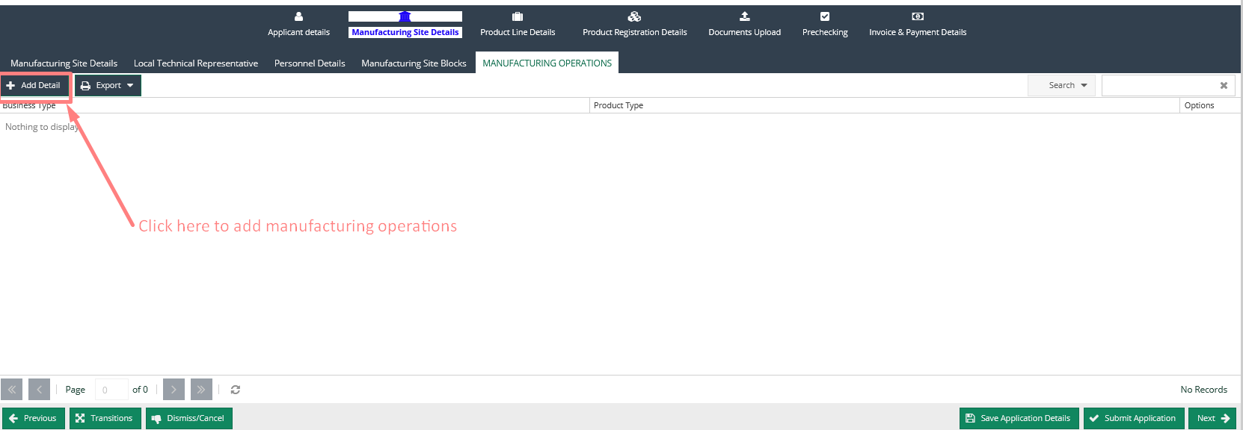

**Manufacturing Operation pop up form**

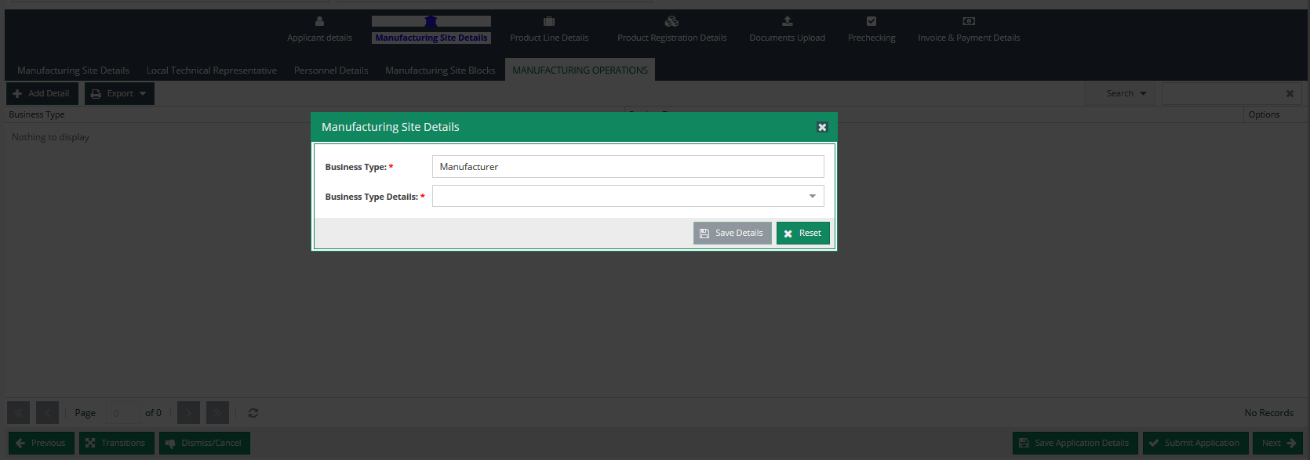

On save the added record is added to the grid with an option to **edit** or **delete**

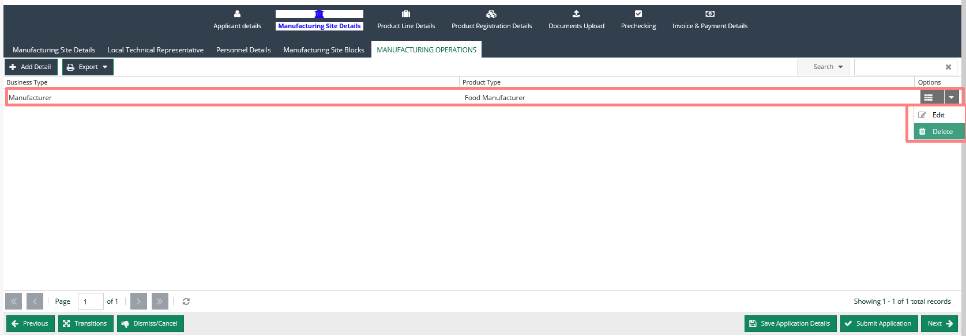

On Personnel Details it opens the form for Contact person to choose Applicant.

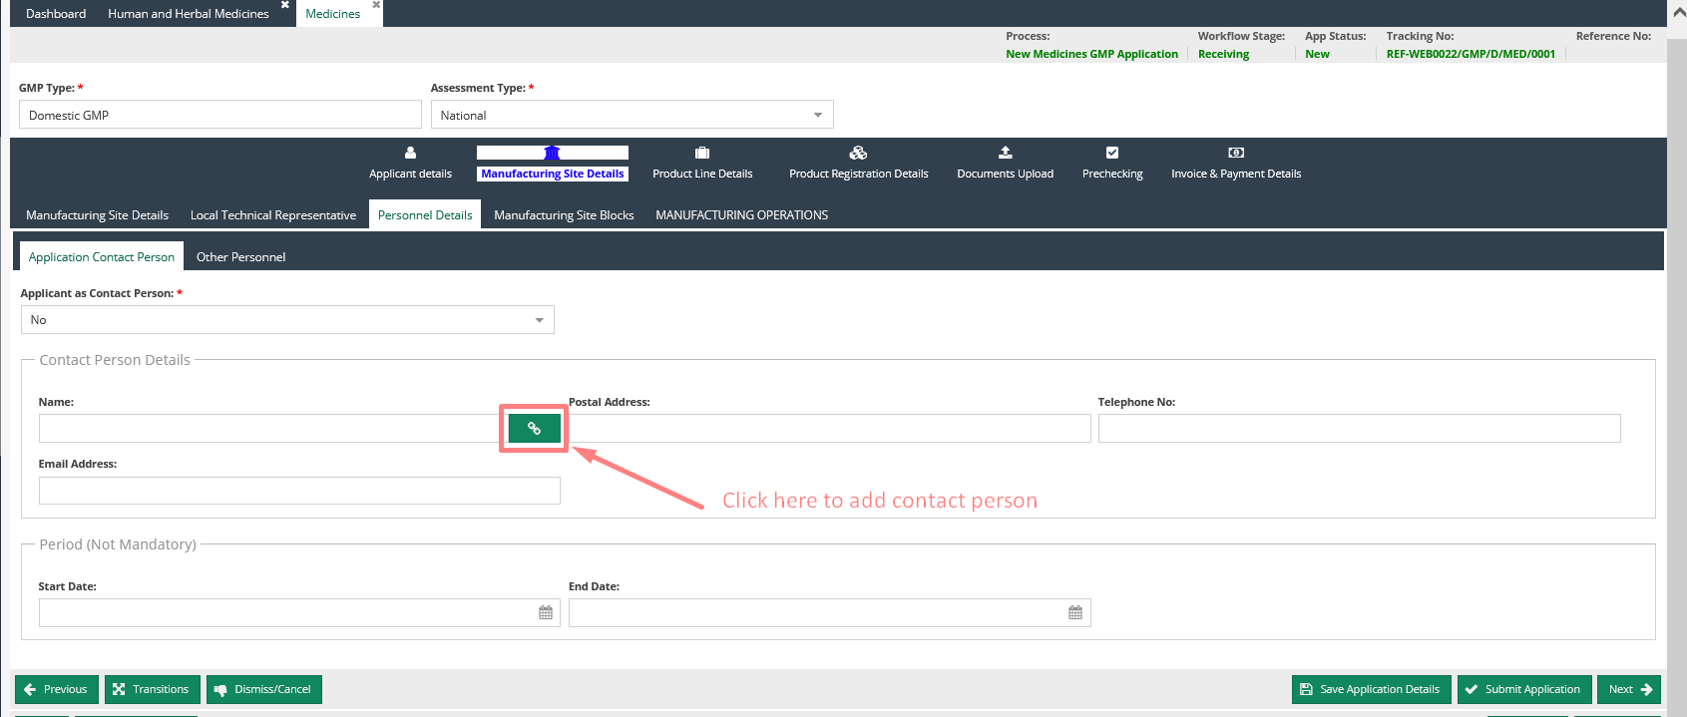

To add a new personnel, double-click on the user select button then navigate to Add Personnel Section and fill in all the required details to add a new trader.

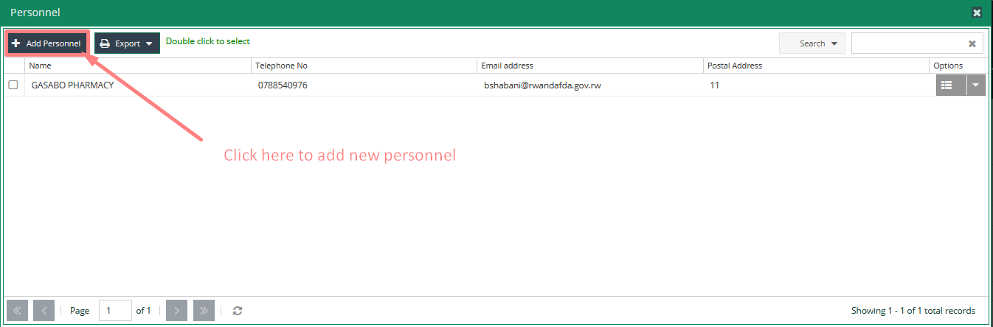

**Step 3 Product Line Details**

To Add Product Line Details, navigate through the grid and select product line category, then add the required details and click the update product line details button to save as shown below.

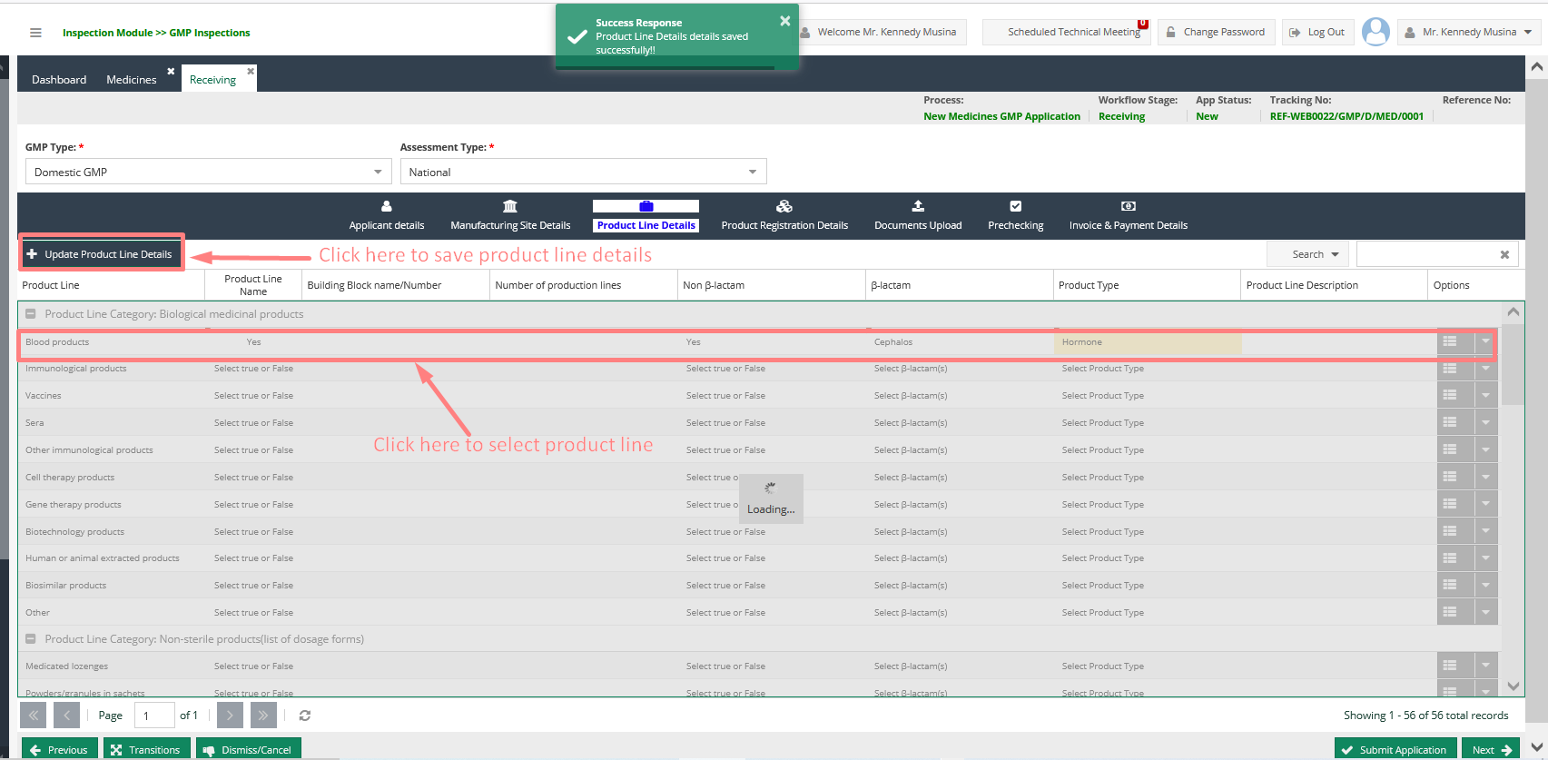

**Step 4 Product Registration Details**

This option facilitates the addition of product registration details as shown below

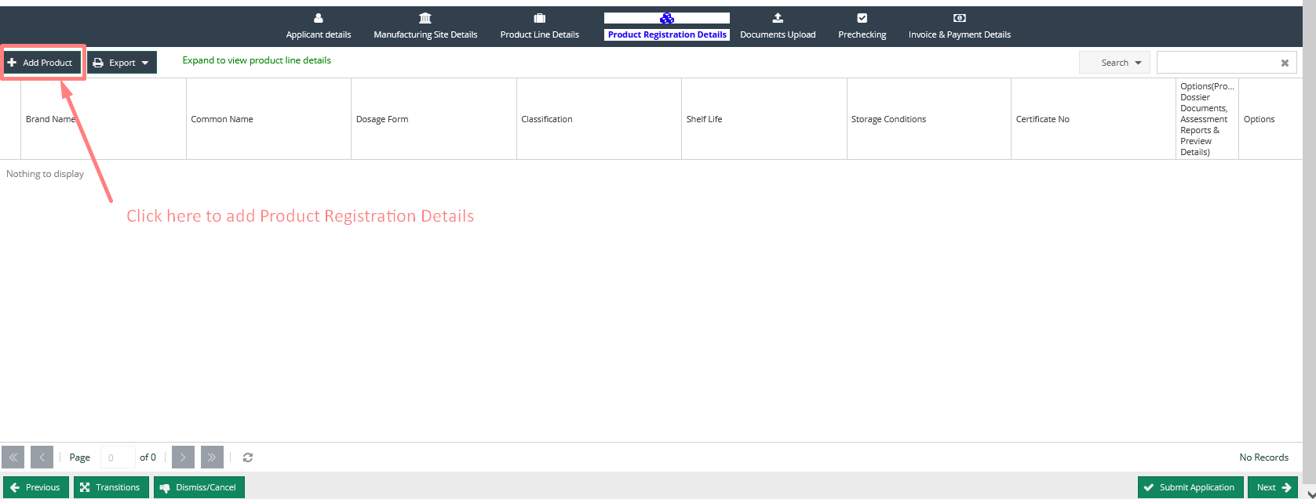

When **Add Product** button is clicked the pops up product selection screen is displayed, navigate to **Add Selected** Section and select the product line details and save:

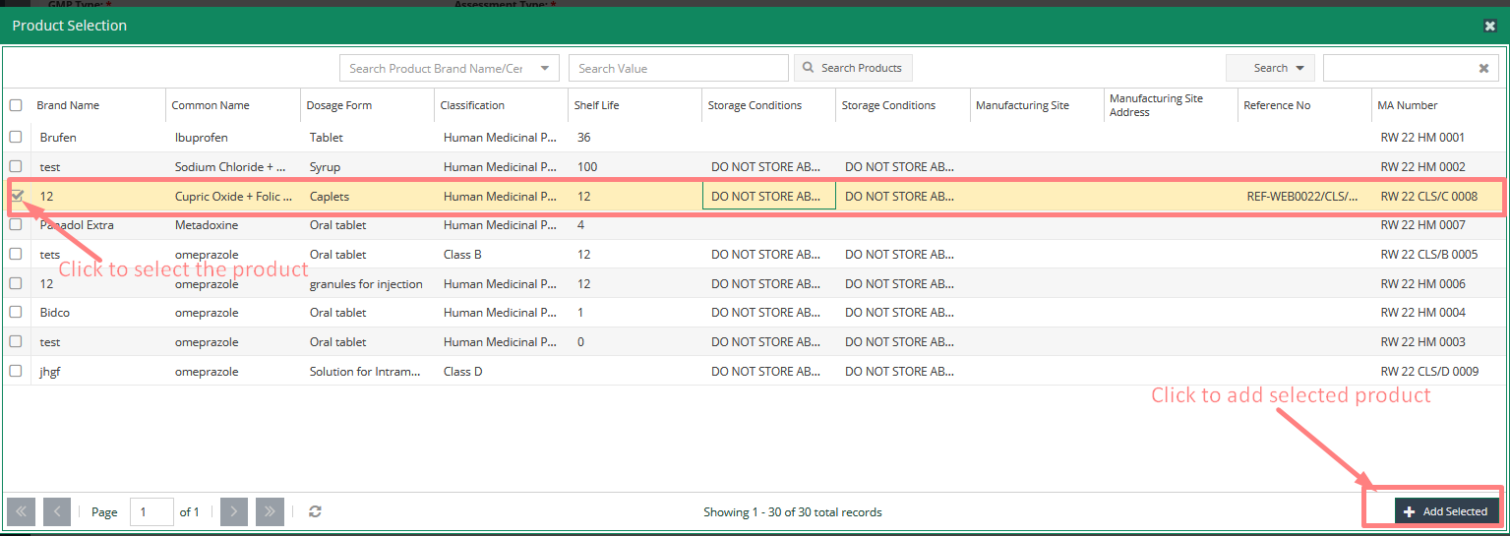

On save the added record is added to the grid with an option to **edit** or **delete** product line

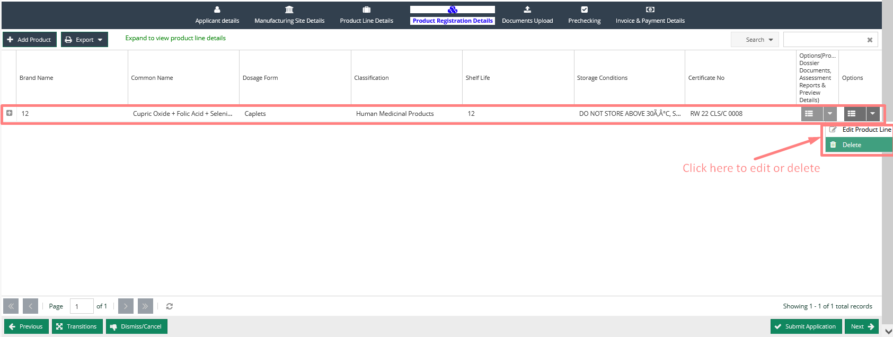

**Step 5 Document Upload**

1. This option facilitates the upload of GMP documents as shown below 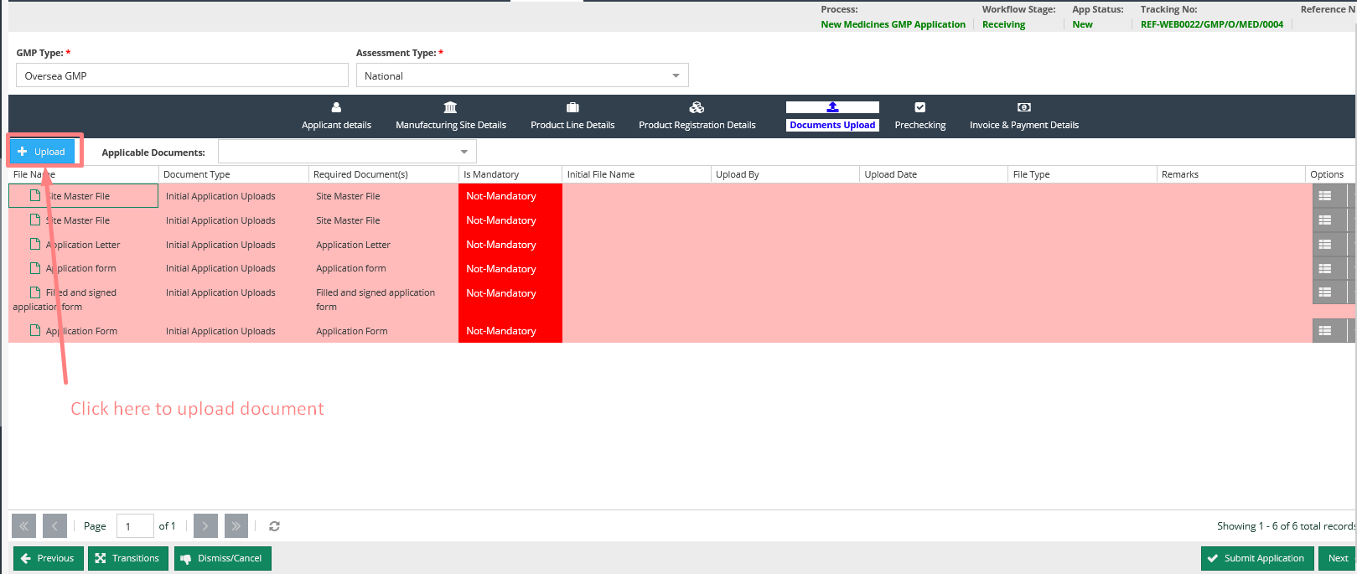

2. Documents are displayed in the document grid as shown below with options to preview, update, delete, and viewing of the document revisions. 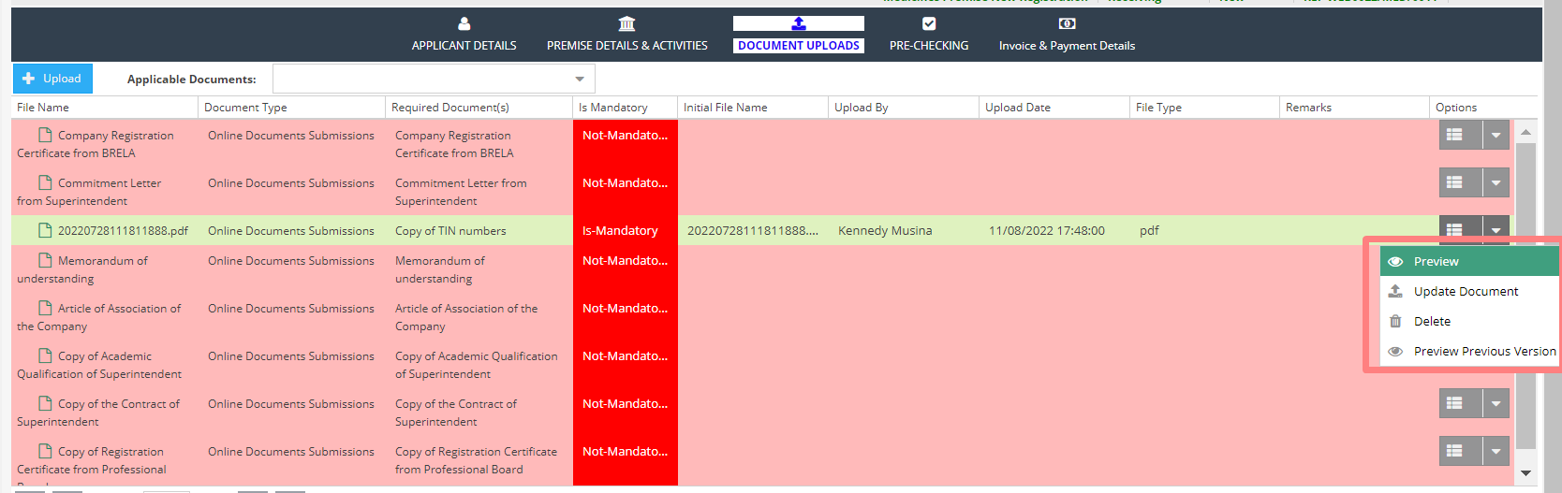

**Step 4 Pre Checking**

This Option facilitates the prechecking of the product details as shown below

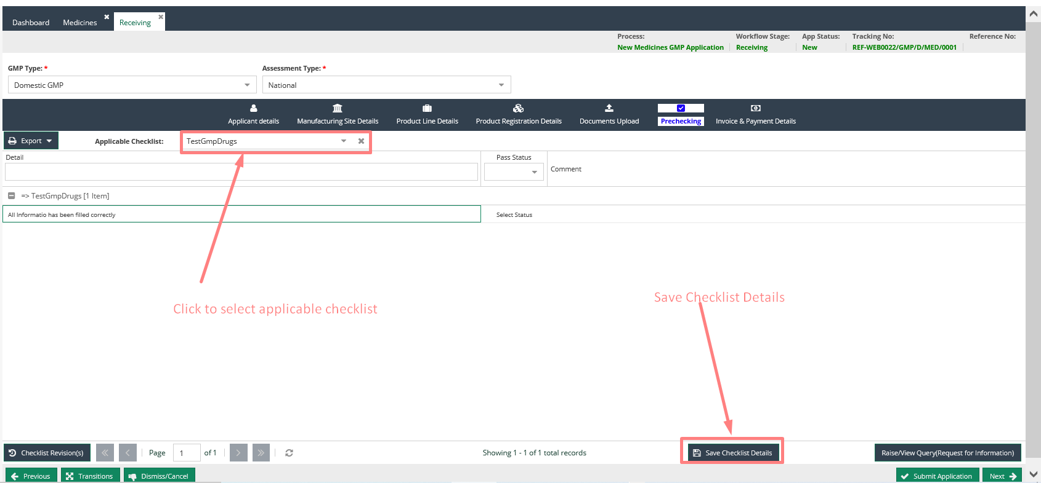

**Step 5 Invoicing and provision of payment details**

**Invoice generation**

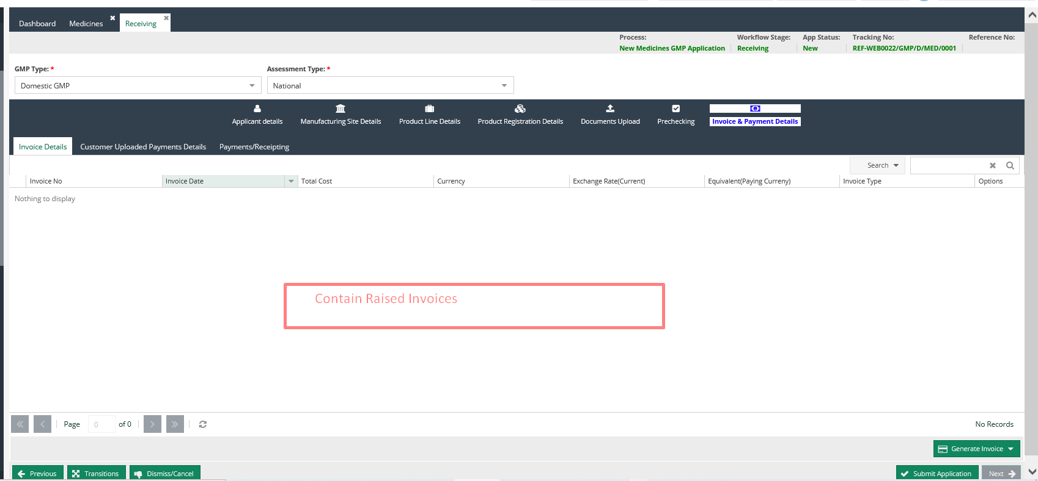

1. On clicking raise invoice quotation window is shown and on pressing Generate Invoice, from the viewed quotation and invoice is generated. 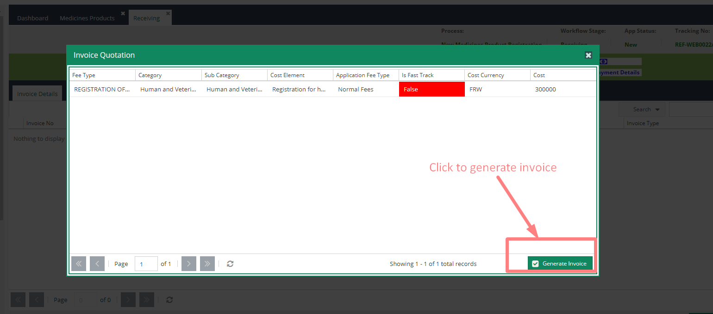

2. Unique invoice number is assigned to the generated invoice and the invoice can be printed or previewed using the print option.

**Step 5 Submitting the application for processing**

This is the final stage of the New GMP application process.

To submit the application, press the **submit** button at the bottom of the interface.

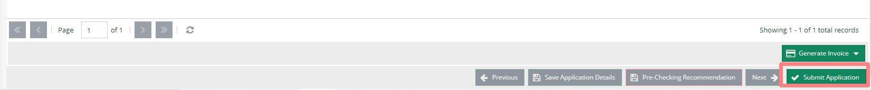

In case all was done correctly a submission window pops up where the user clicks the **Submit Application** button to apply to the next stage as defined in the workflow. 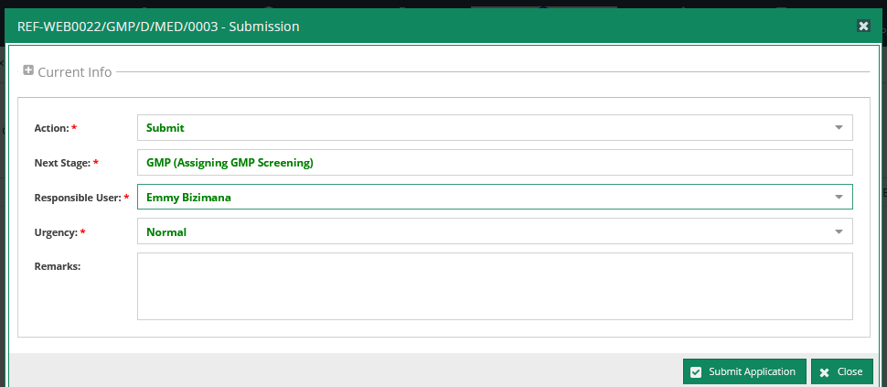

On pressing **submit Application** button, the application is pushed to the next defined stage and the responsible person will see it on their in-trays

# GMP Application Processing

## Receipting and Payment Verification Process

During payment verification process;

1. Double click the application from the in tray to load it for payment verification
2. At the verification stage users can;
   1. Preview Clinical Trial information by pressing the view application details button
   2. Preview raised invoices
   3. Preview any uploaded payment proof.
3. On the raised invoice you are able to preview received payments and preview the receipts as well as capture payment manually while the option is still supported.
4. Once the payment has been captured the application can be submitted for processing by pressing the submit button

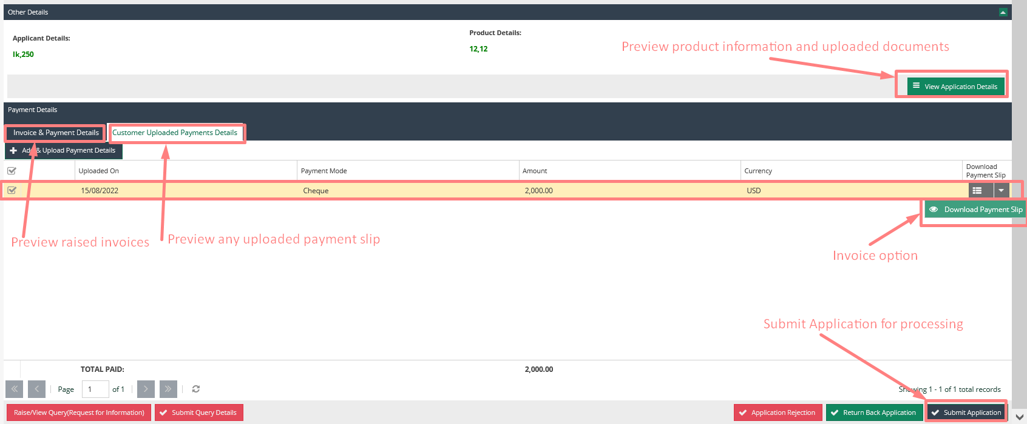

1. Then click submit an application from this pop-up screen.

## GMP (Assigning GMP Screening)

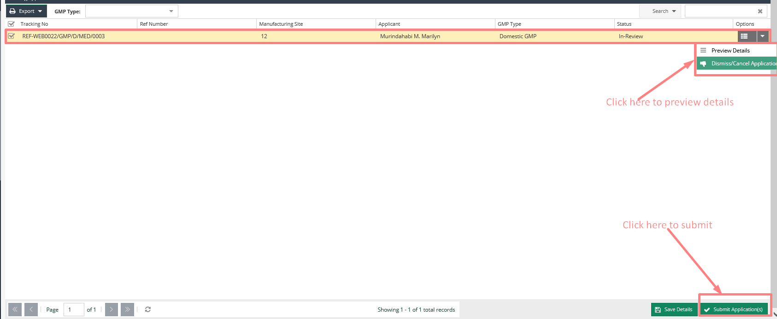

To submit an application to GMP Assigning Screening follows the following procedure;

1. While at the GMP assignment page select the application you want to assign to the screening stage

2. Then click the submit application button.

3. On the pop-up window that appears select action as submit for screening then select the person to perform the screening as a responsible user.

4. Then click submit an application from this pop-up screen.

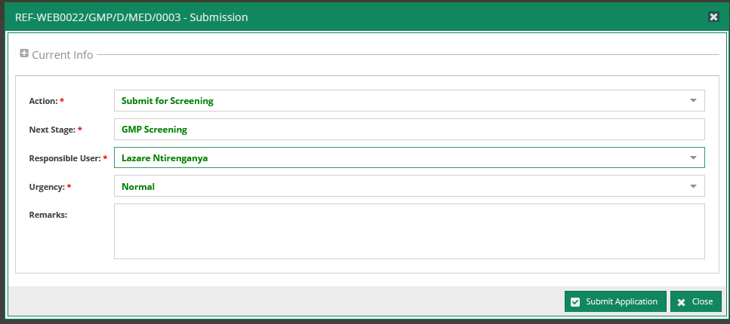

## GMP Screening

To complete the screening process the checklist provided should be checked alongside the data provided by the applicant.

After checking the checklist, then click Submit Application button to take it to the next stage.

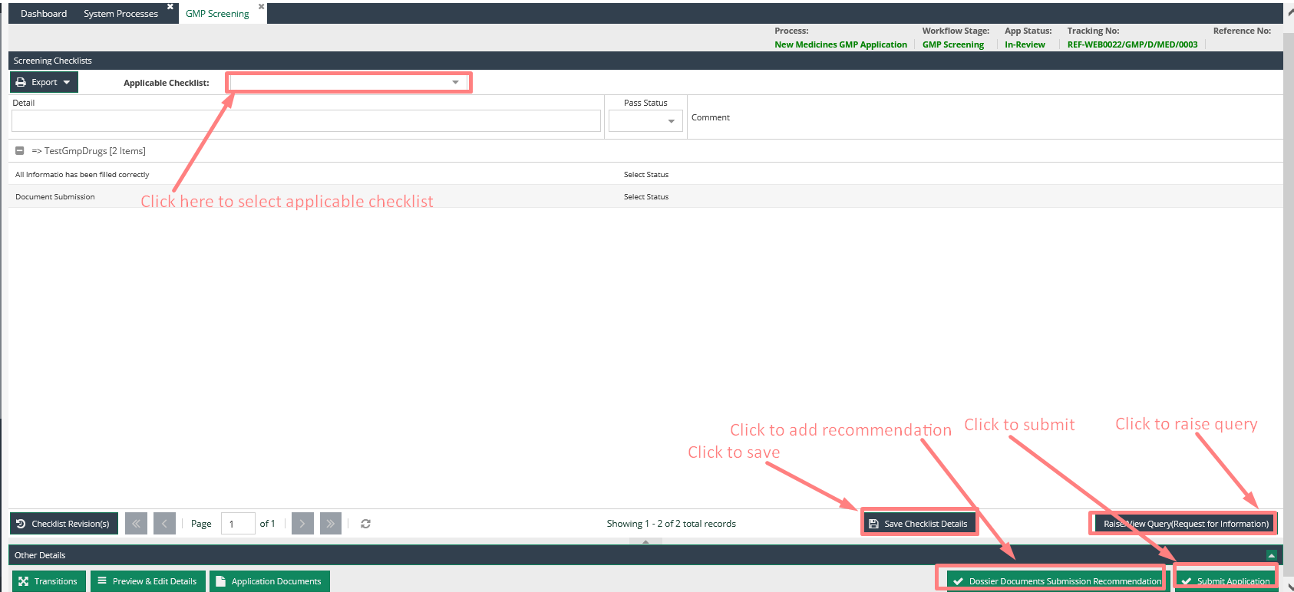

### Then click submit an application from this pop-up screen.

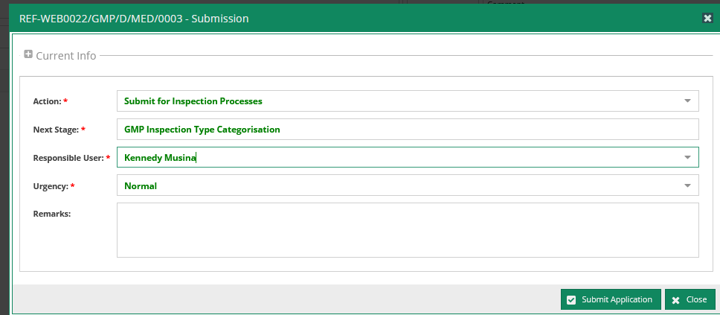

## GMP Inspection Type Categorization

To access the application, double-click on the application from the in-tray for GMP Inspection Categorization to open the Categorization Details form.

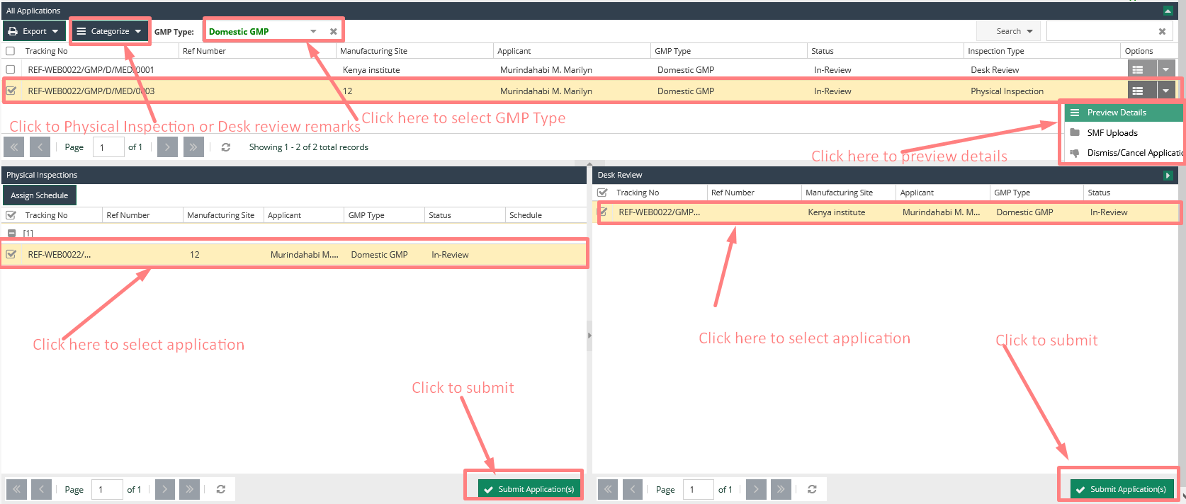

Select the GMP type, click categorize button and add the remarks from the pop-up form then save.

Then Click submit application button depending on the inspection category i.e Desk Review or Physical Inspection.

### Click submit an application from this pop-up screen.

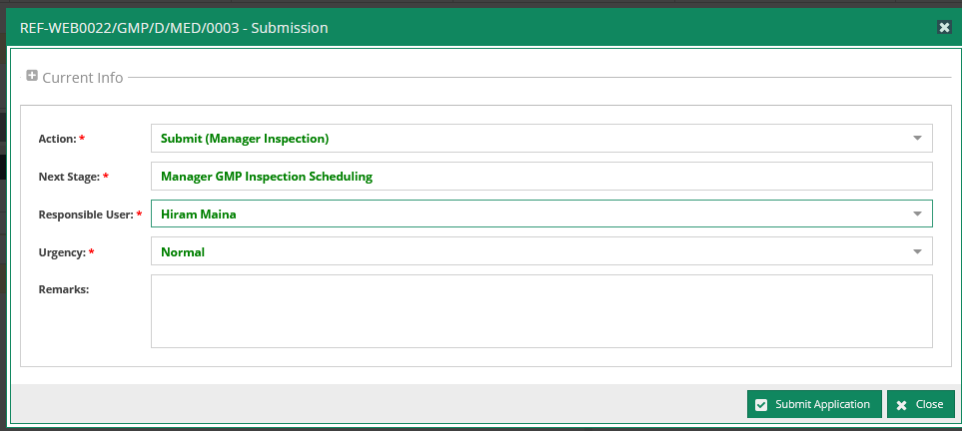

## Manager GMP Inspection Scheduling

To access the application, double-click on the application from the in-tray for Manger GMP scheduling to opens Inspection Schedule Details form.

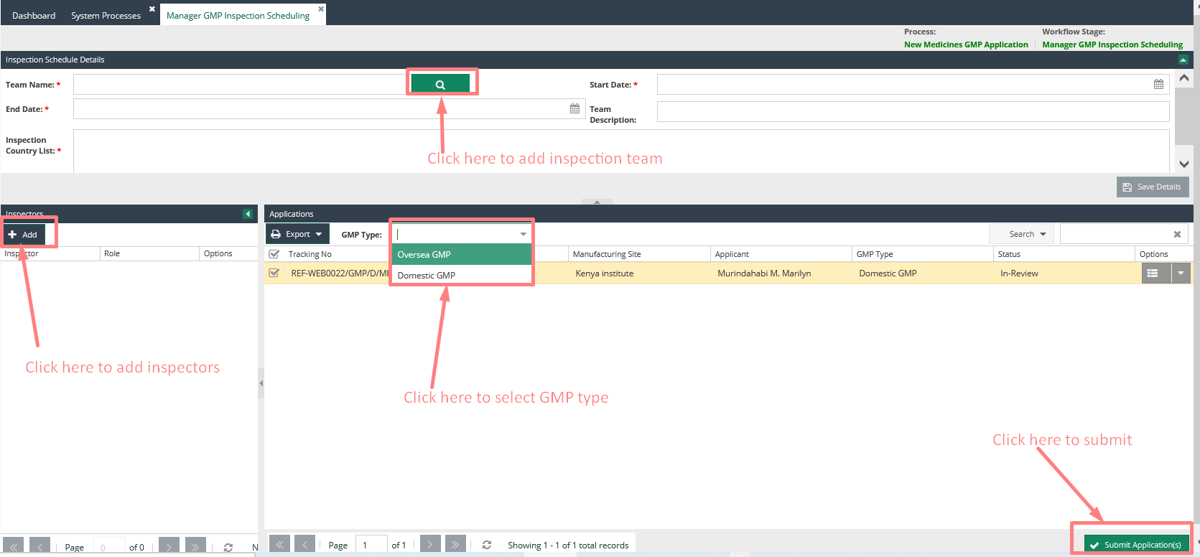

On Select Inspection team the window pop-up with the list of inspection team to be selected. Double-click

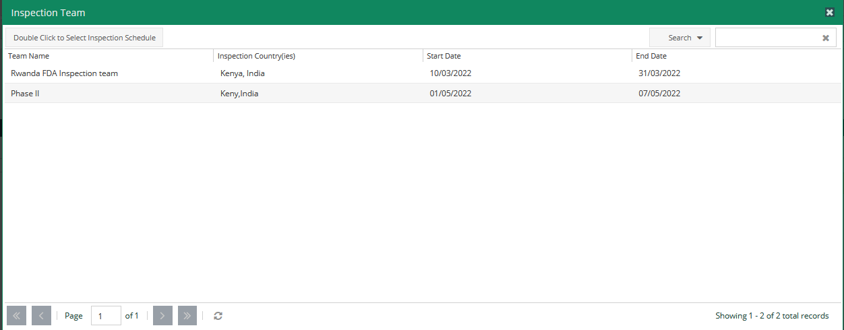

On add Inspectors the window pop-up with the list of inspectors Details to be selected. Select Inspectors and save.

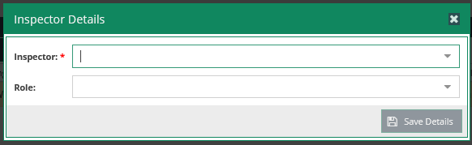

Then click the submit application button.

On the pop-up window that appears select action as submit for Inspection Stage then select the person to perform the screening as a responsible user. Then click submit an application from this pop-up screen.

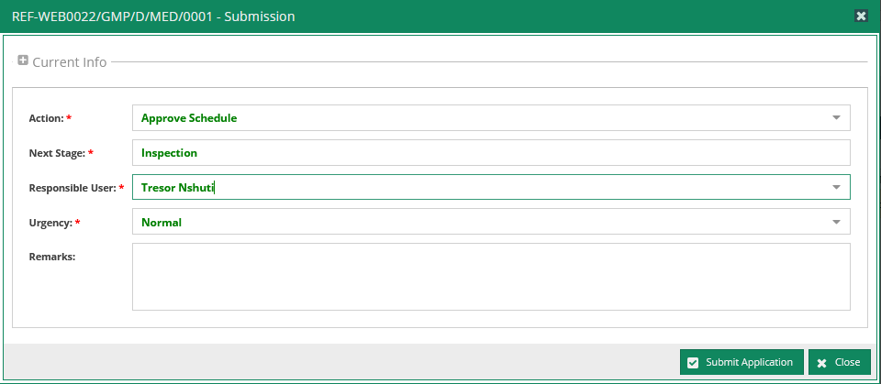

## Inspection stage

At this stage, one is provided with an option to upload a document, inspect Report checklist, preview and recommend the application before submitting it to the next stage.

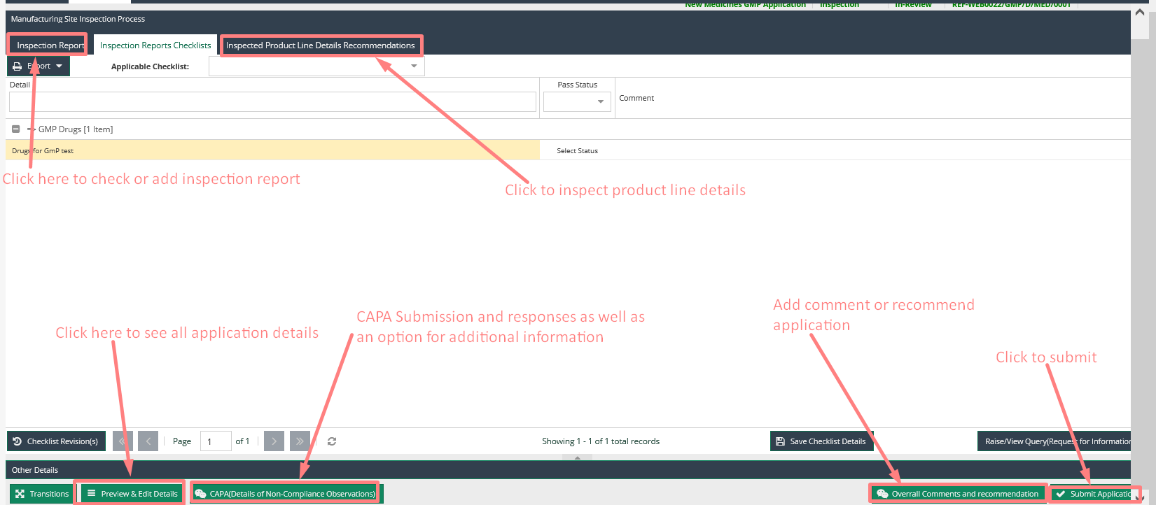

On click submit application button.

On the pop-up window that appears select action as submit for Inspection Report Review Stage the select the person to perform the Report Review as a responsible user. Then click submit an application from this pop-up screen.

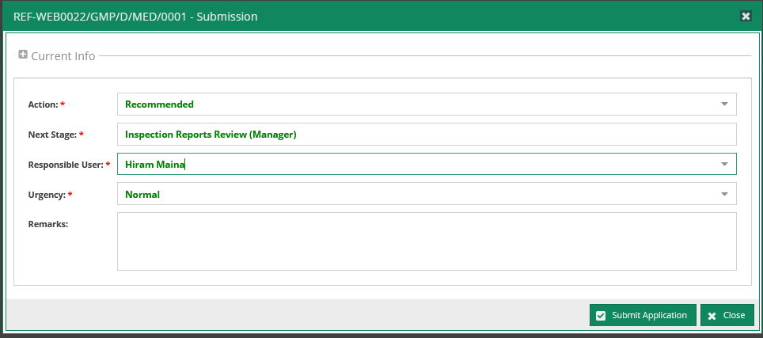

## Inspection Reports Review (Manager)

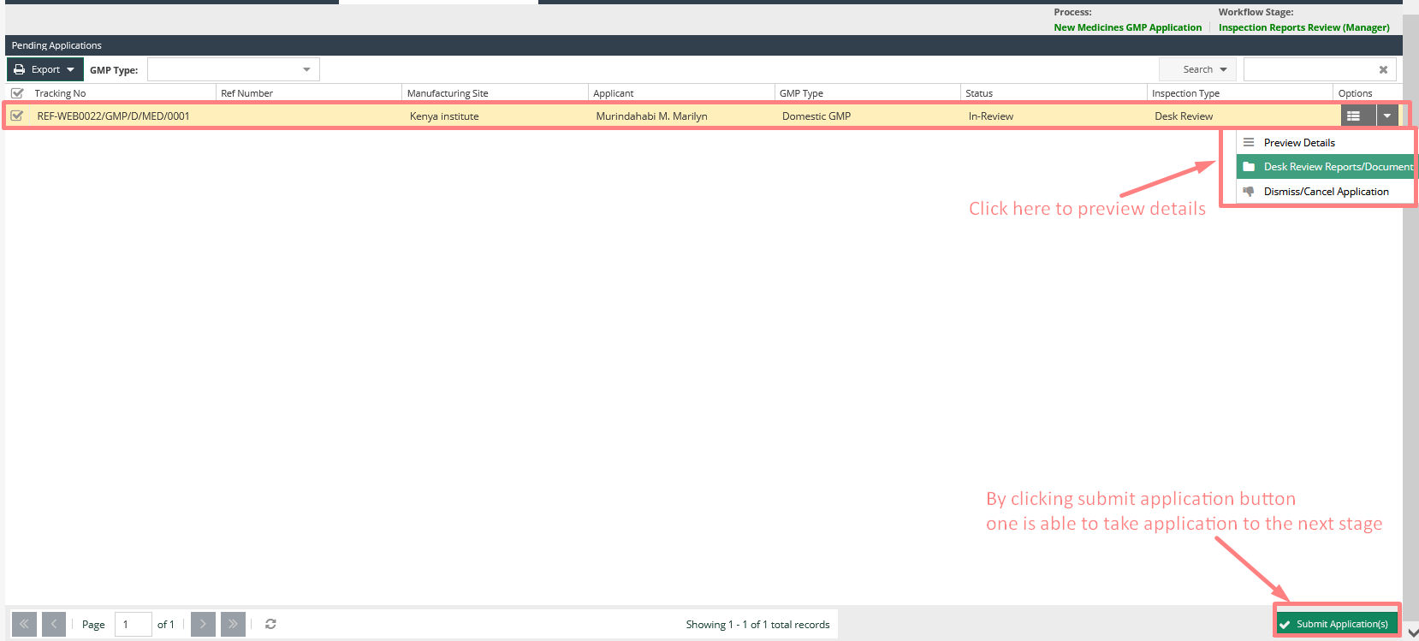

To submit an application to Report Review stage after inspection follows the following procedure;

1. While at the manager Reports Review page select the application you want to assign to the TC Meeting Scheduling stage

2. Then click the submit application button.

3. On the pop-up window that appears select action as submit for TC meeting then select the person to perform the screening as a responsible user.

4. Then click submit an application from this pop-up screen.

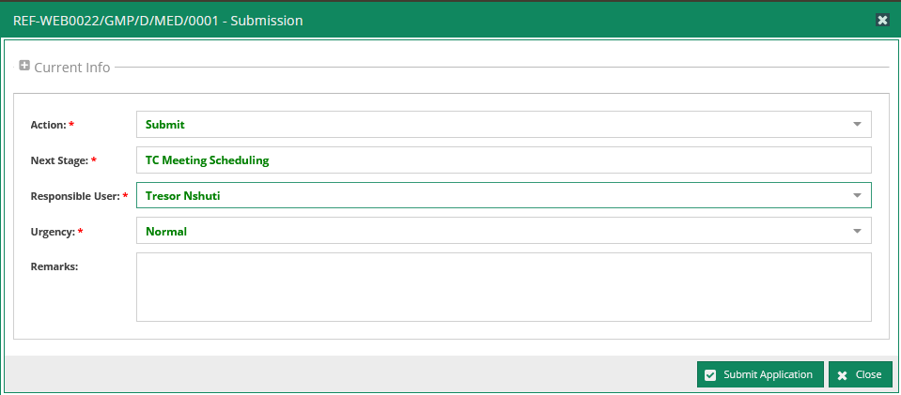

## TC Meeting Scheduling

To access the application, double-click on the application from the in-tray for TC meeting scheduling to opens Meeting Details form.

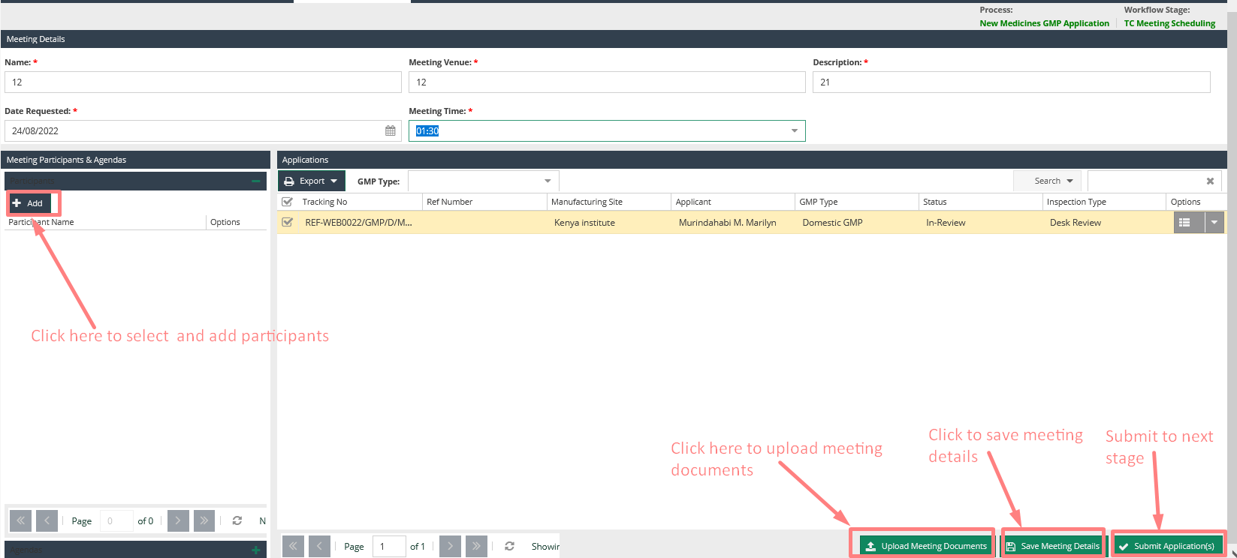

On add Participants the window pop-up with the list of participants to be selected. Select Participants and save. Also navigate to External Participant Section and fill in all the required details to add new participant.

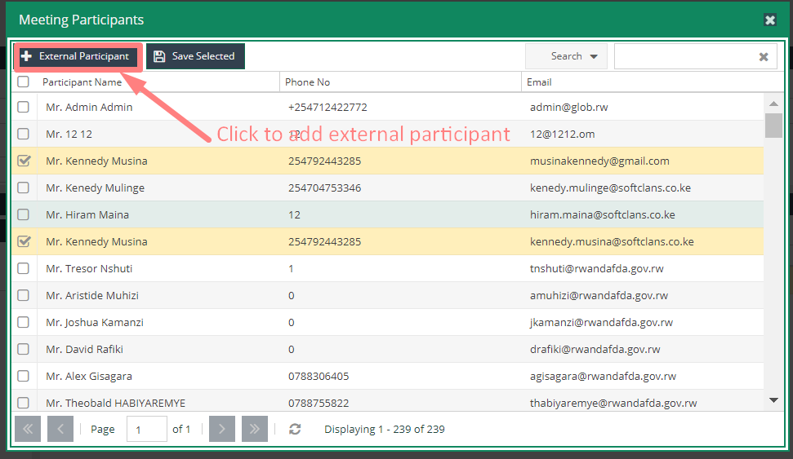

Then click the submit application button.

On the pop-up window that appears select action as submit for Review Recommendation Stage the select the person to perform the screening as a responsible user. Then click submit an application from this pop-up screen.

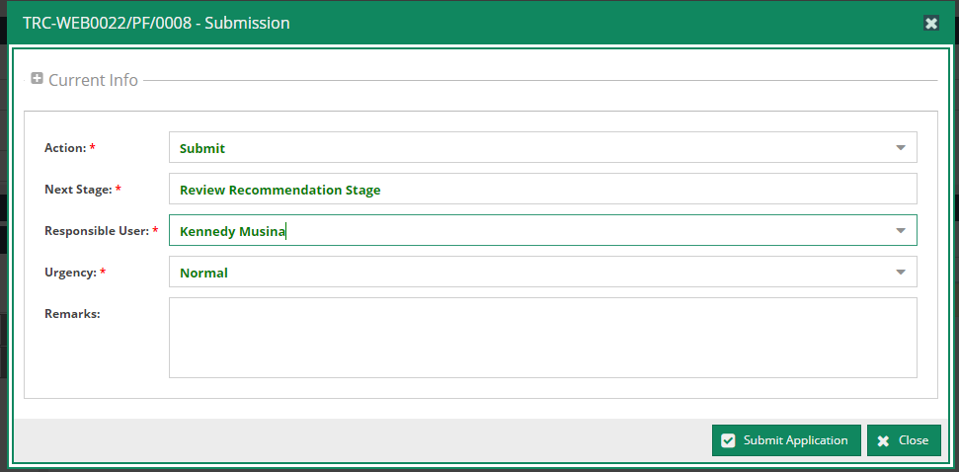

## TC Recommendation Review

One is required to double-click the application from the in-tray to process recommendation review then on the action button click TC Recommendation.

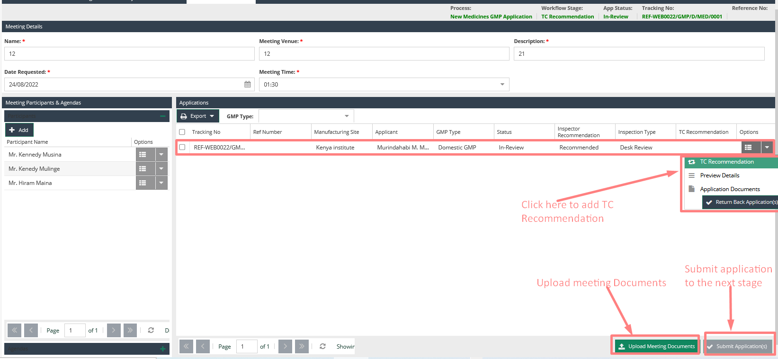

Add recommendation on the pop-up screen that appears then save.

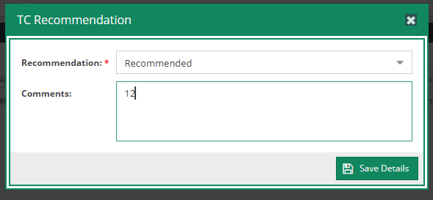

Submit application to the next stage.

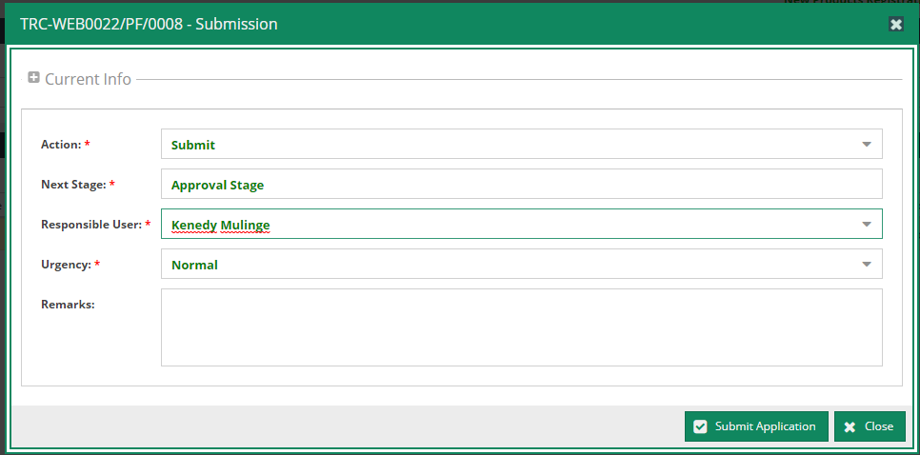

## Review & Approval

The manager is provided with an option to review and recommend the application before submitting it to the next stage for site approval.

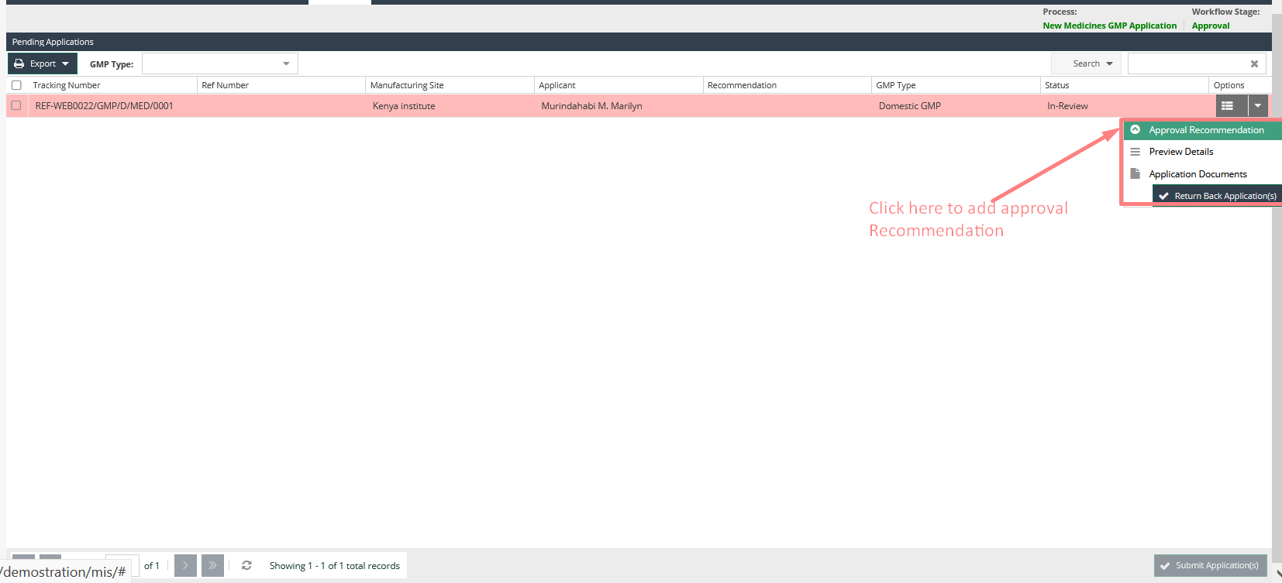

One is required to select the application to process approval then on the action button click Approval Recommendation and add recommendation on the pop-up screen that appears then submit application to the next stage.

Note: the Certificate Number is Auto generated.

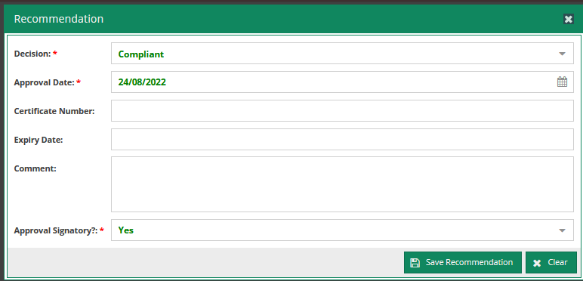

## Communication with Applicant Process

At this stage it provides options to print certificates, update signatory and preview details as well as inspection of documents.

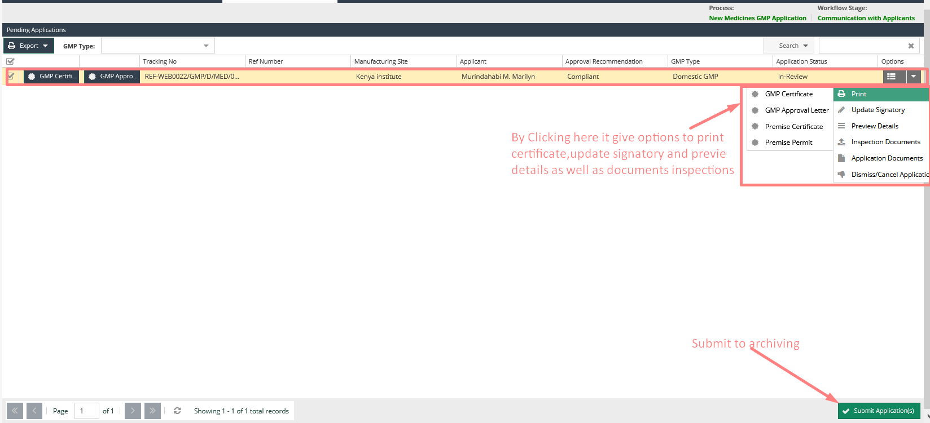

On clicking GMP Certificate, the Certificate is displayed with the option to print.

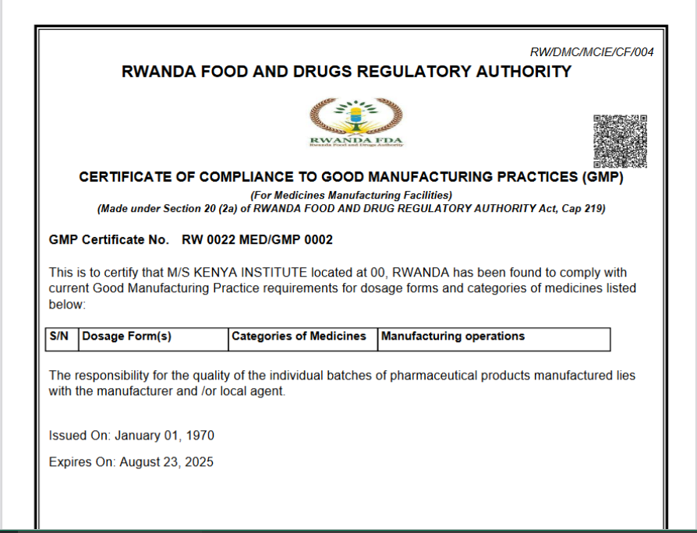

Once the final decision is recharged and communication has been done to the applicant, the application can be archived so that it no longer exists in the processing pipeline but only as a finished task in reports.

To archive,

1. Submit the application from final stage to archive stage as shown below.

## Management of the GMP Databases

The following section allows for management of the GMP database on a read only basis.

The following features are implemented.

* Database details
* Filtering details
* Export Options

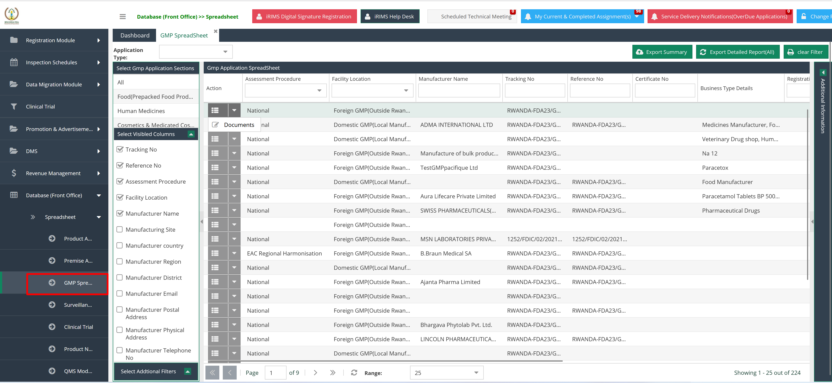

Management of the GMP Register

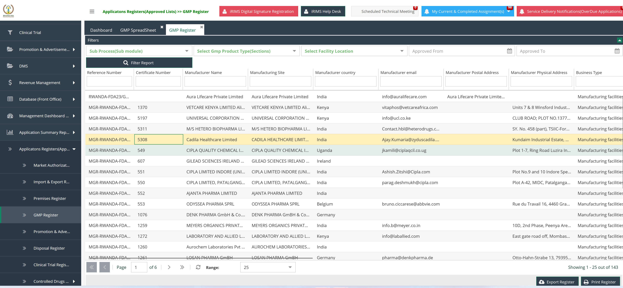





Contact Information

Rwanda Food & Drugs Authority

